**GUJARAT TECHNOLOGICAL UNIVERSITY**

Chandkheda, Ahmedabad, Affiliated

 

G. H. PATEL COLLEGE

OF

ENGINERRING AND TECHNOLOGY

A Report on

**Home Automation using Arduino**

Under subject of

DESIGN ENGINERRING-2A

B.E. III, Semester- V

**COMPUTER BRANCH**

Submitted by:

Group no. : 15

|  |  |  |
| --- | --- | --- |
| **Sr.** | **Name of student** | **Enrollment no.** |
| 1. | Kushal Shah | 150110107027 |
| 2. | Vipal Lad | 150110107028 |
| 3. | Chinmay Patel | 150110107036 |
| 4. | Payal Thakkar | 160113107010 |

**Prof. Kinjal Joshi**

(Faculty Guide)

**Dr. Maulika Patel**

(Head of the Department)

Academic year

(2017-18)

**Index**

1. Introduction

1.1 Abstract

1.2 Design Thnking

2. Modified Canvases

2.1 A-E-I-O-U Framework

2.1.1 Activity Canvas

2.1.2 Environmental Canvas

2.1.3 Interactive Canvas

2.1.4 Object Canvas

2.1.5 User Canvas

2.2 A-E-I-O-U Conclusion

2.3 Empathy Mapping

2.4 Ideation Canvas

2.5 Product Development Canvas

2.6 Mind Mapping

2.7 Importance of Log Book

2.8 Literature Review

2.9 LN Matrix

3. Design For Cost

**Chapter: 1 Introduction**

The name of our team is Fantastic Four, as name shows

There are four members in group and there name and numbers are as follows:

1. Kushal Shah 150110107027
2. Vipal Lad 150110107028
3. Chinmay Patel 150110107036
4. Payal Thakkar 160113107010

And the general information of the team members is as given below:

And the general information of the team members is as given below:

Kushal Shah belongs to Vadodara and is a 12th pass out and is pursuing his Bachelor’s.

Vipal Lad belongs to Surat and is a 12th pass out and is pursuing his Bachelor’s.

Chinmay Patel belongs to Surat and is a 12th pass out and is pursuing his Bachelor’s.

Payal belongs to Vadodara and is a Diploma graduate from M S University and is pursuing her Bachelor’s.

Our project guide is Prof. Kinjal Joshi . She has completed her M.E from B.V.M Engineering College, V.V. Nagar. She is much innovative and supportive and always there to help us and her unique quality is her motivational support.

**1.1 Abstract:**

Home Automation is an android based application used for controlling different devices at home.

The project helps in supervising several devices from around the globe.

The Home Automation system runs through arduino board connected with internet or wifi. The whole project is android based. User can indirectly access the devices through the android application.

This is done for easy access to the devices from far away locations and for energy saving purposes.

1

**1.2 Design Thinking:**

The plan takes images from motion capture camera and it detects abnormal activities by applying different motion detecting algorithms. If detection found, a portion of clip is stored on cloud and accessing platforms like windows (Desktop/PC) and android (Mobile) and only authenticated and authorized users can access the cloud.

2

**Chapter: 2 Modified Canvases**

**2.1 A-E-I-O-U Frameworks**

**2.1.1 Activity Canvas:**

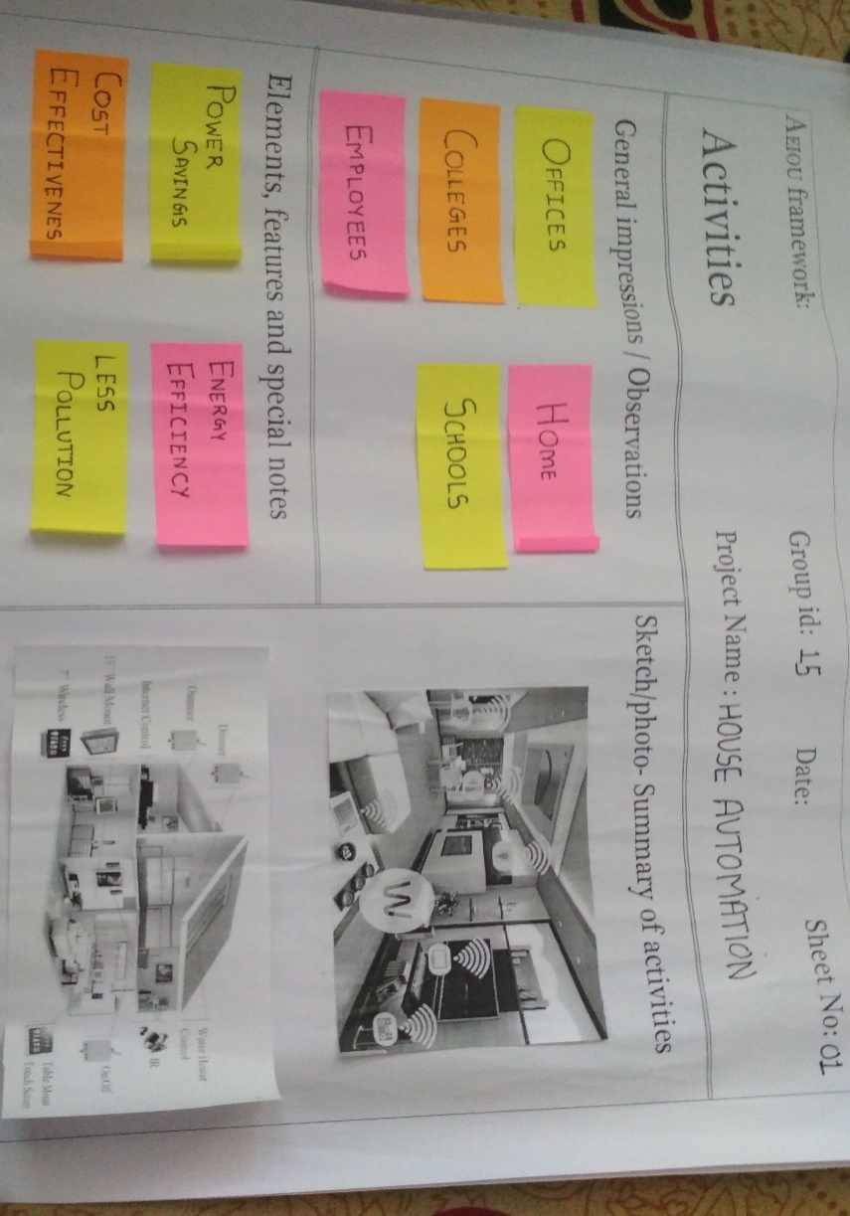

**General Impressions/Observations:**

* Offices
* Colleges
* Schools
* Employees

**Elements, Features and Special Notes:**

* Power savings
* Energy efficiency
* Less pollution
* Cost effectiveness

3

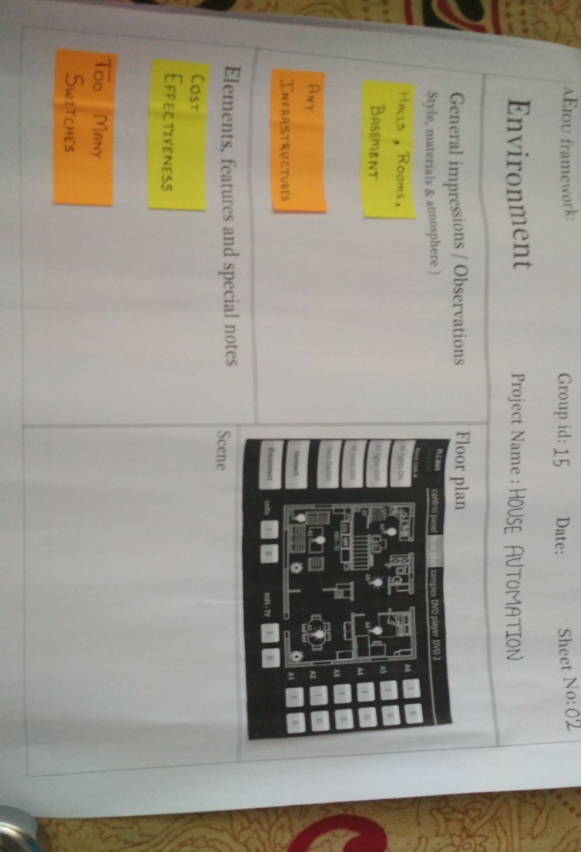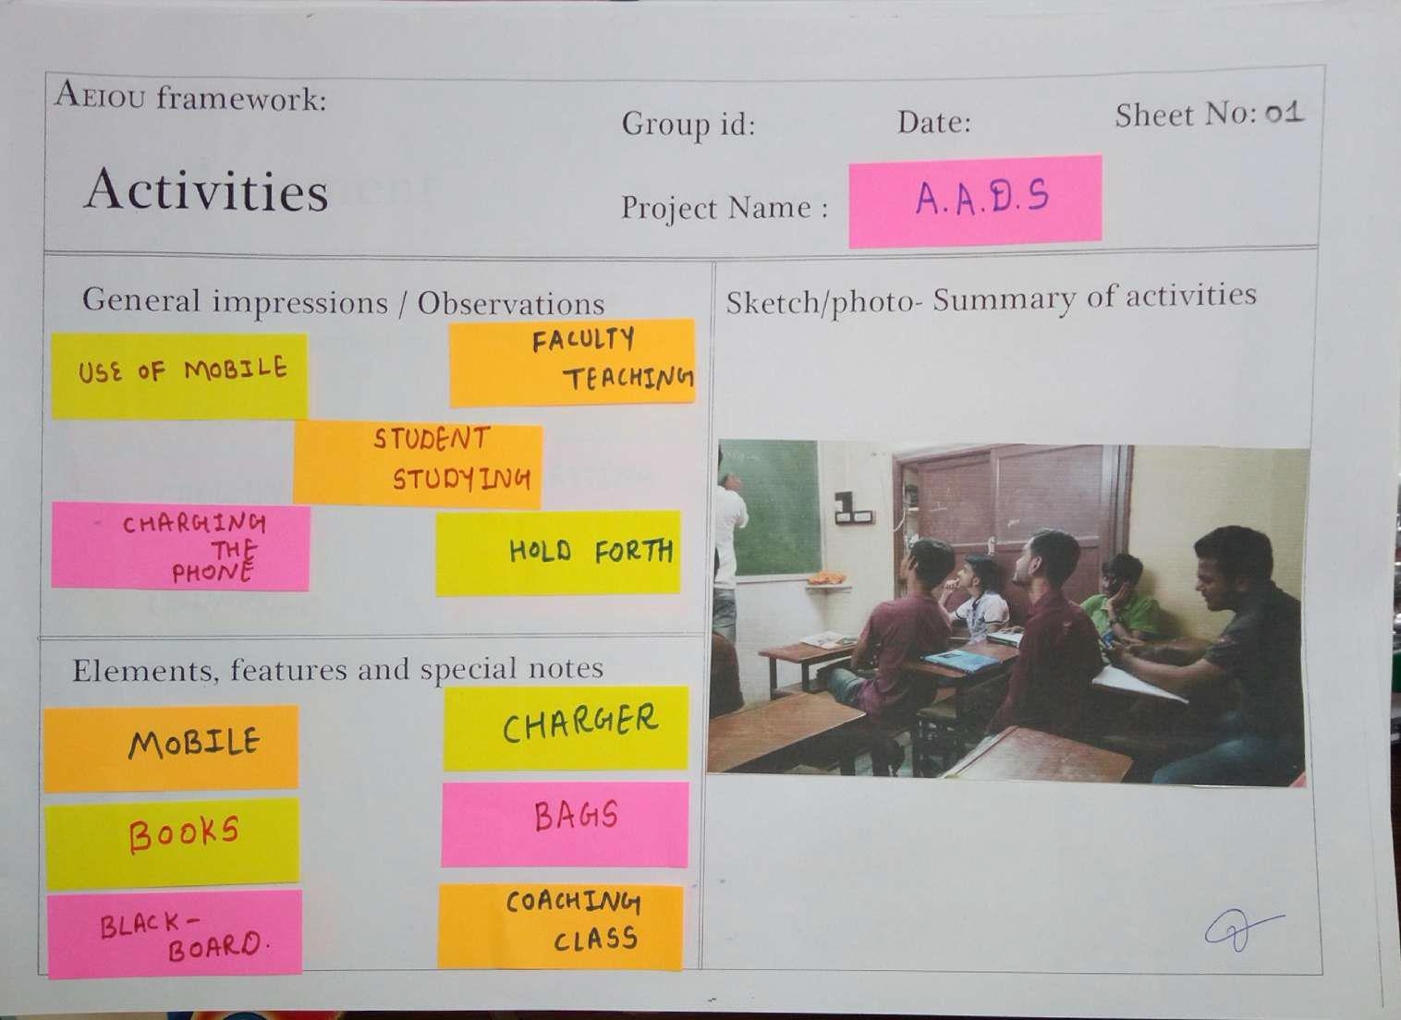**2.1.2 Environment Canvas:**



**General Impressions/Observations:**

* Halls
* Rooms
* Basements
* Any infrastructures

**Elements, Features and Special Notes**

* Cost effectiveness
* Too many sitches

4

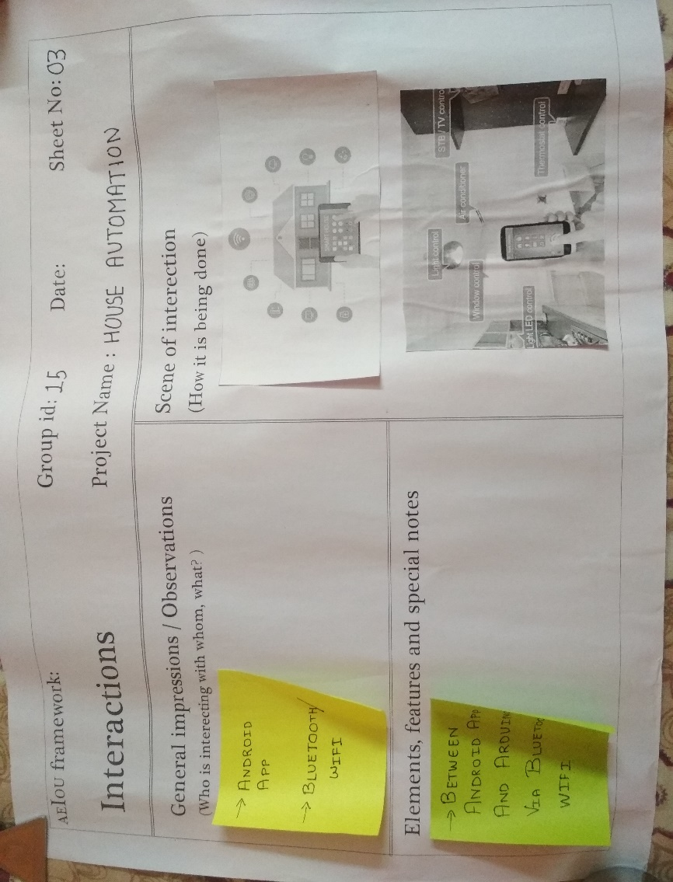**2.1.3 Interaction Canvas:**



**General Impressions/Observations:**

* Android App
* Bluetooth/Wifi

**Elements, Features and Special Notes**

* Between Android App and Arduino via Bluetooth/Wifi

5

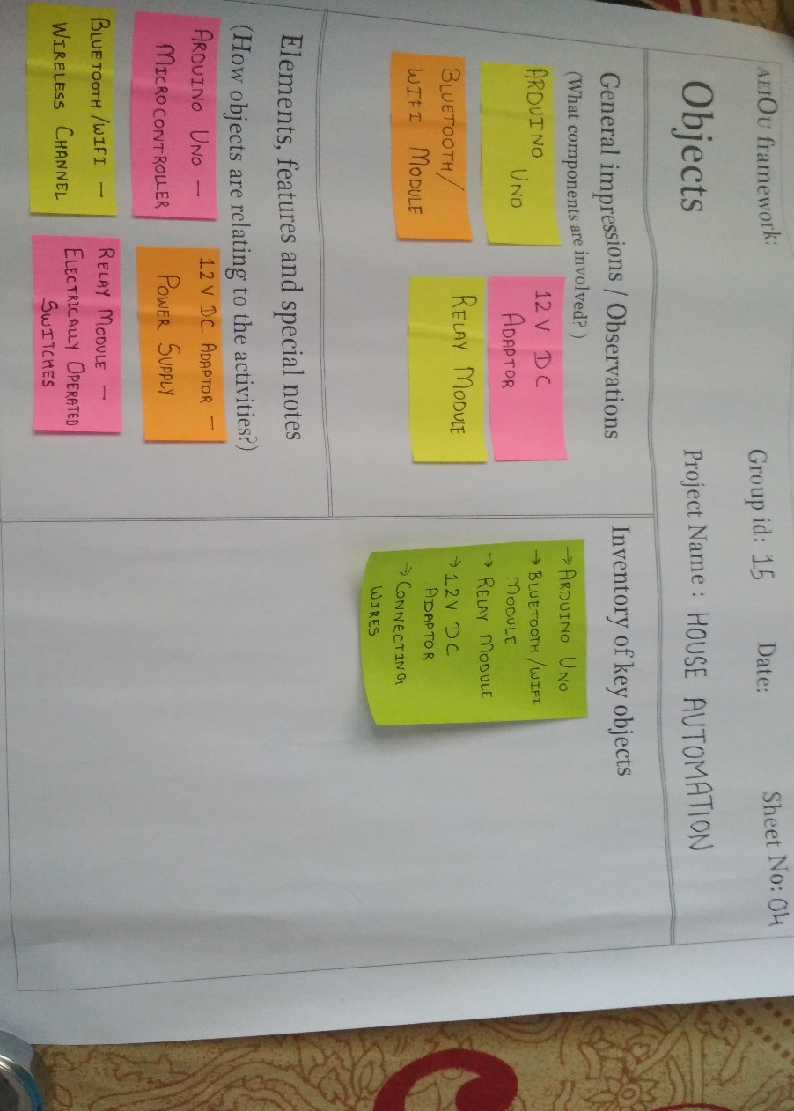**2.1.4 Objects Canvas**



**General Impressions/Observations:**

* Aurduino Uno
* 12v DC adaptor
* Relay module
* Bluetooth/ifi module

**Elements, Features and Special Notes**

* **Arduino Uno:**microcontroller
* **12v DC adaptor:**power supply
* **Relay module:**electrically operated switches
* **Bluetooth/wifi module:** ire less channel

6

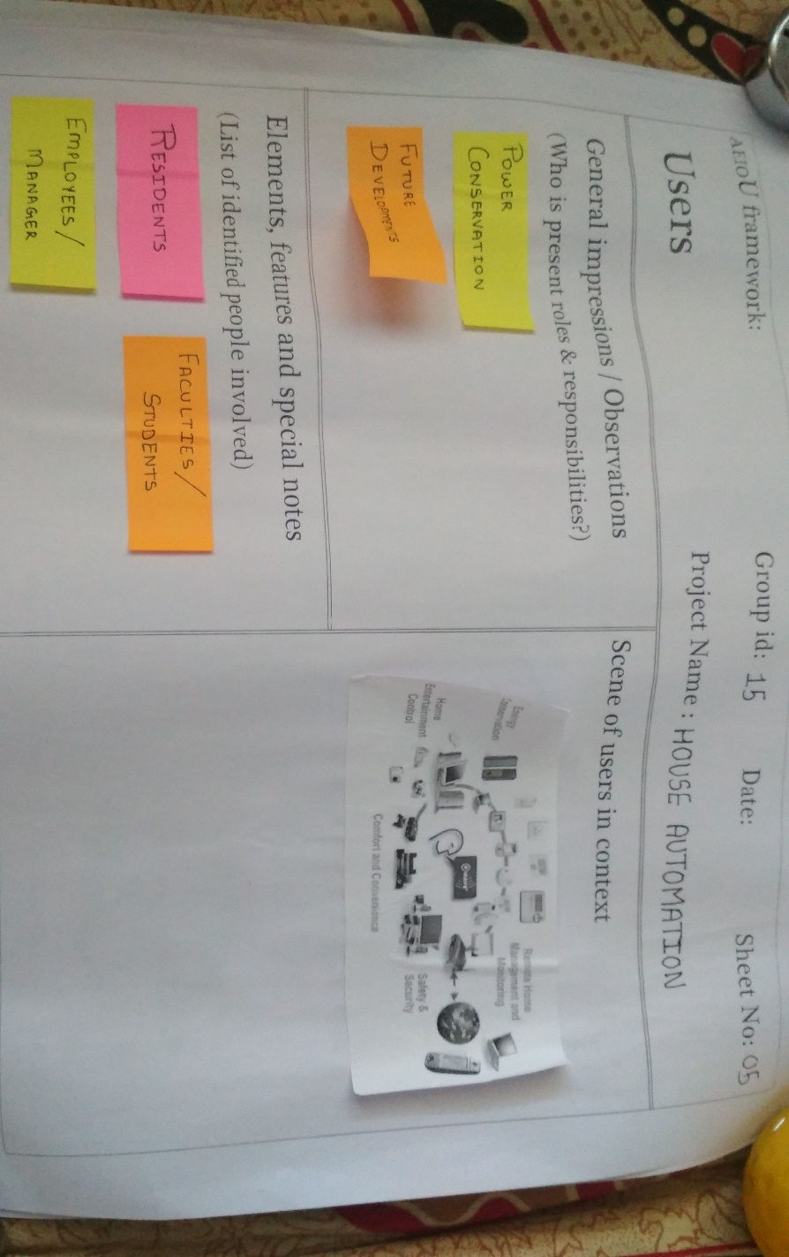**2.1.5 Users Canvas**



**General Impressions/Observations:**

* Poer conservation
* Future development

**Elements, Features and Special Notes**

* Residents
* Faculty/Students
* Employees/Manager

7

**2.2 A-E-I-O-U Conclusion:**

From the A-E-I-O-U Framework, we concluded

* General activities being performed around the occurrence of abnormal activities.
* Environmental factors that affect the detection of such activities.
* Interactions that had to be done to students, teachers, security etc to get information on these activities.
* Objects found or being used by students performing abnormal activities.
* General users whose lives the project will effect.

8

**2.3 Empathy Mapping**



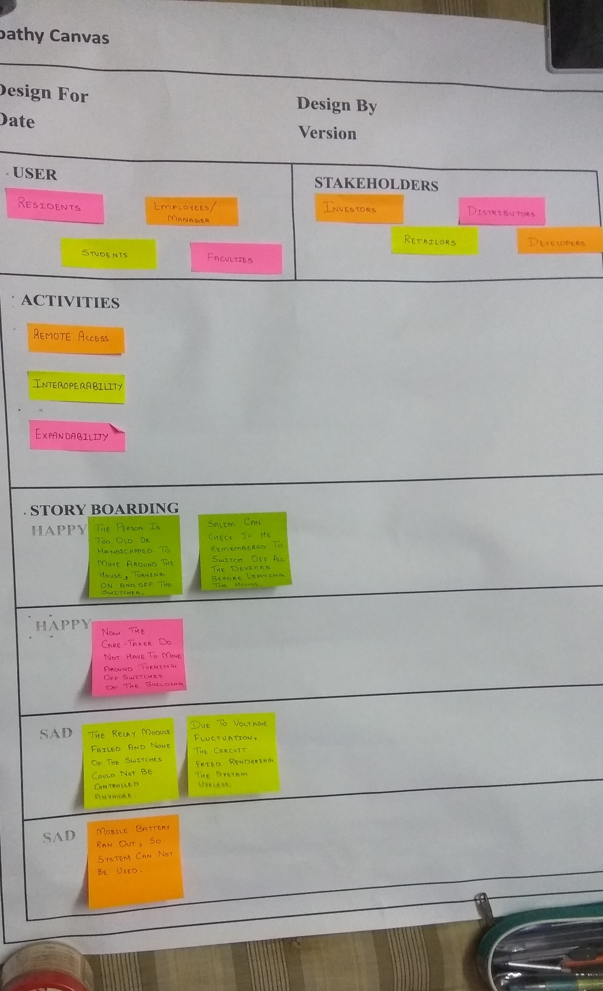

9

**Users**

* residents
* Manager/Employees
* Students
* faculties

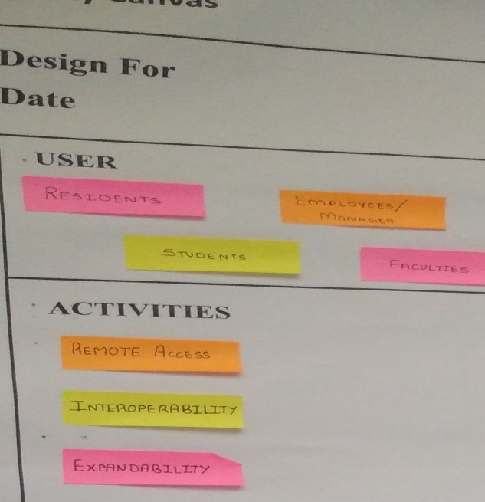

**Stakeholders**

* Hotel Management
* Public Works Department
* Students
* Faaculties

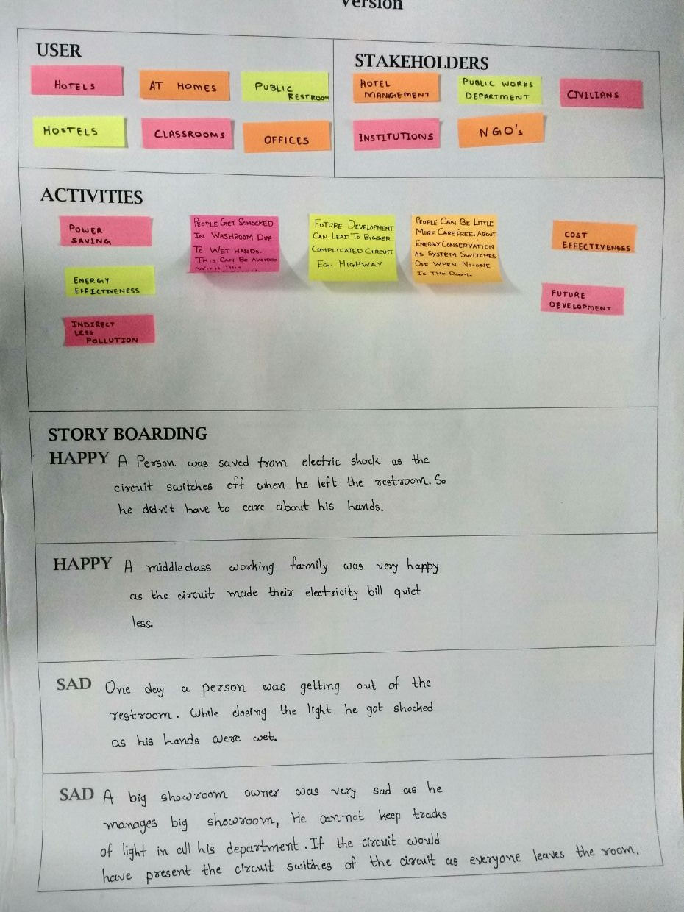

10

**Activities**



* Remote access
* Interoperability
* Expandability

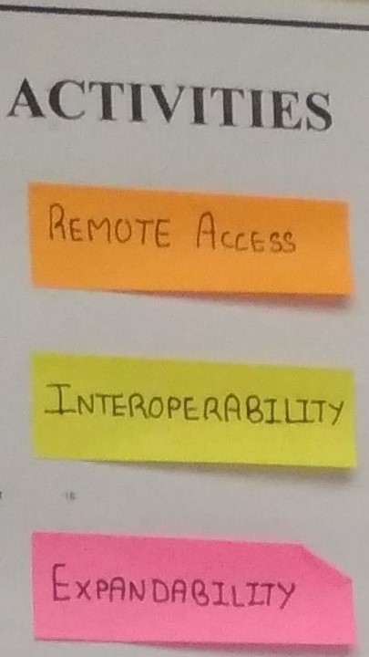

**Stories:**

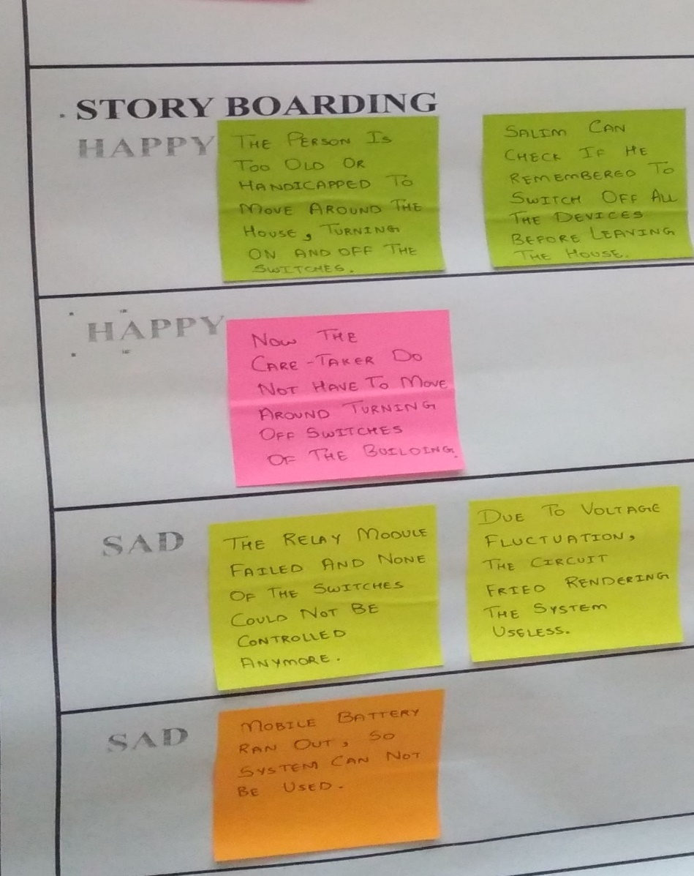

**Conclusion from Empathy Canvas**

To get new ideas, try to find solutions of the daily life problems, to act systematically to approach towards the problem, be ethical and creative, and just be different if you can’t be the best.



12

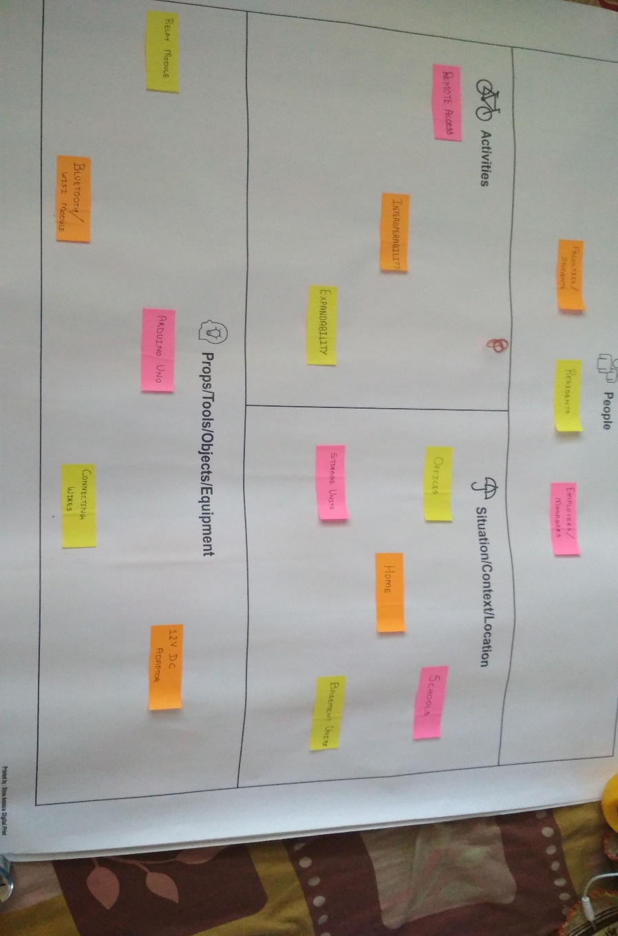**2.4 Ideation Canvas**



The idea of the product leads to the designing of the process which is a cycle process of designing producing product in small quantity evaluate it and again design for better quality of the product.

**People**



There is no. of people involved or affected in this process, they can be

**People**

Students

Faculties

Residents

Employees/Managers

13

**Activities**

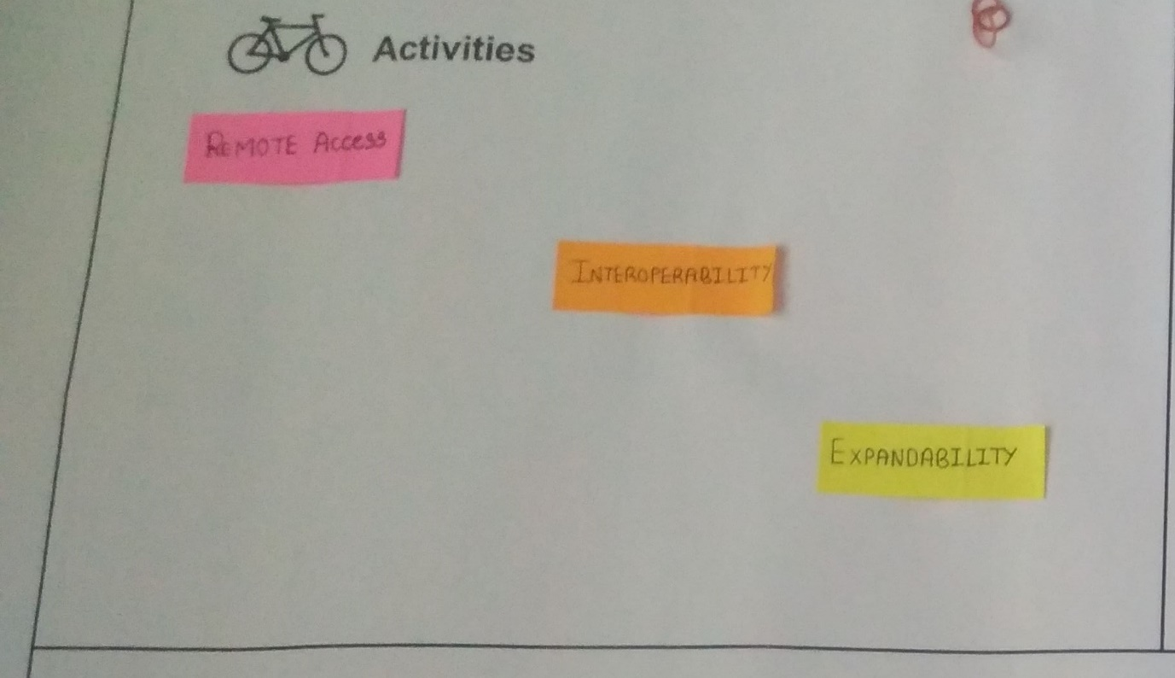



* Remote access
* Interoperability
* Expandability

14

**Situations/Context/Location**

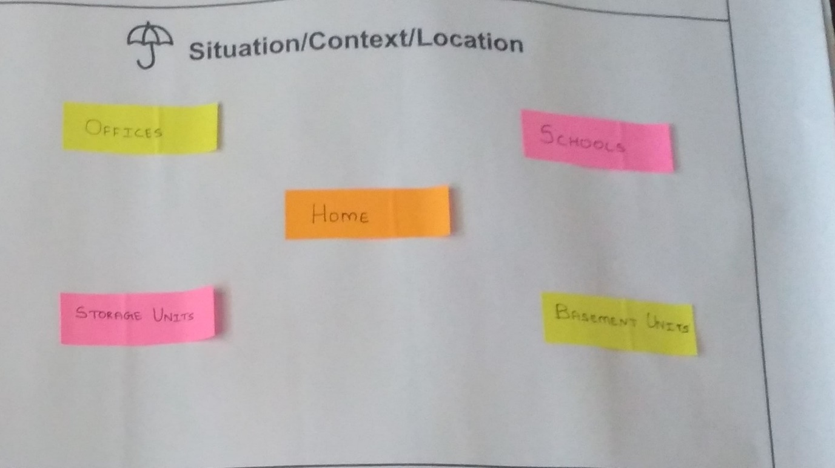

* offices
* home
* storage units
* schools
* basement units

15

**Props/Possible solutions**

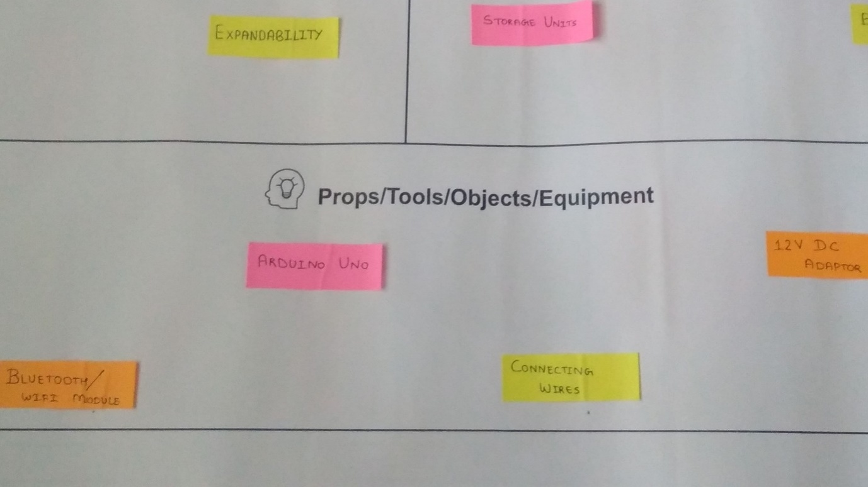



* Relay module
* Bluetooth module/wifi module
* Arduino module
* Connecting wires
* 12V DC adaptor

16

**2.5 Product Development Canvas**

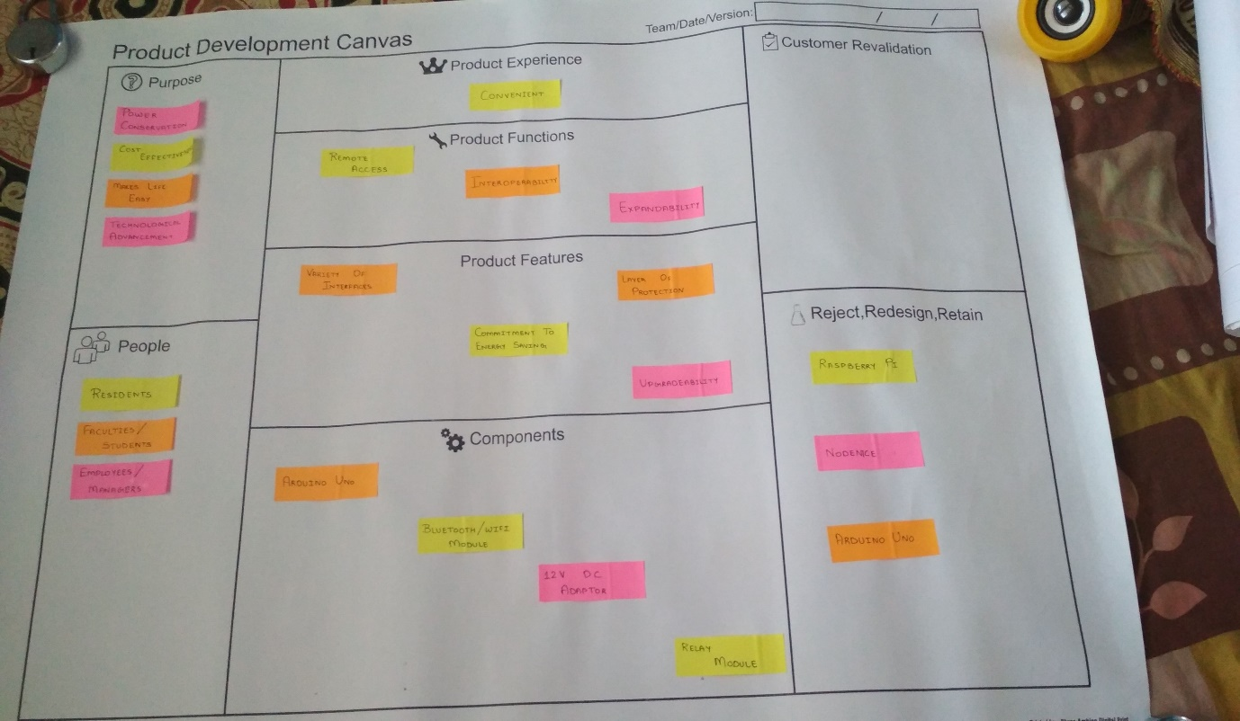

**Purpose**



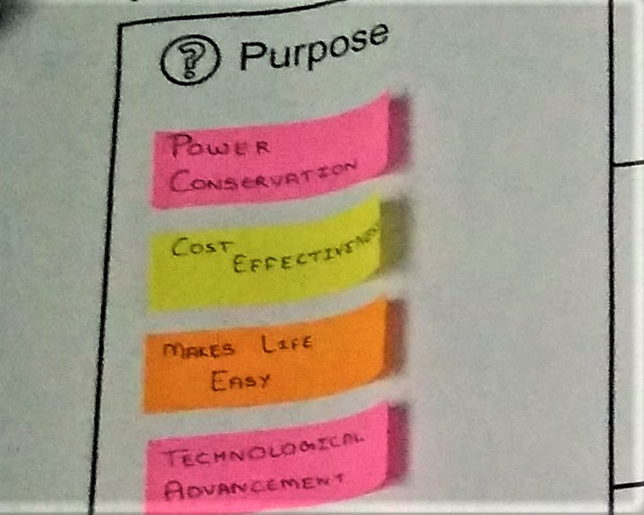

17

* less power conservation
* Cost effectiveness
* Makes life easy
* Technological advancement

**Product features**



Product features are as follows:

* Variety of interfaces
* Commitment to energy saving
* Layer of protection
* Upgradability

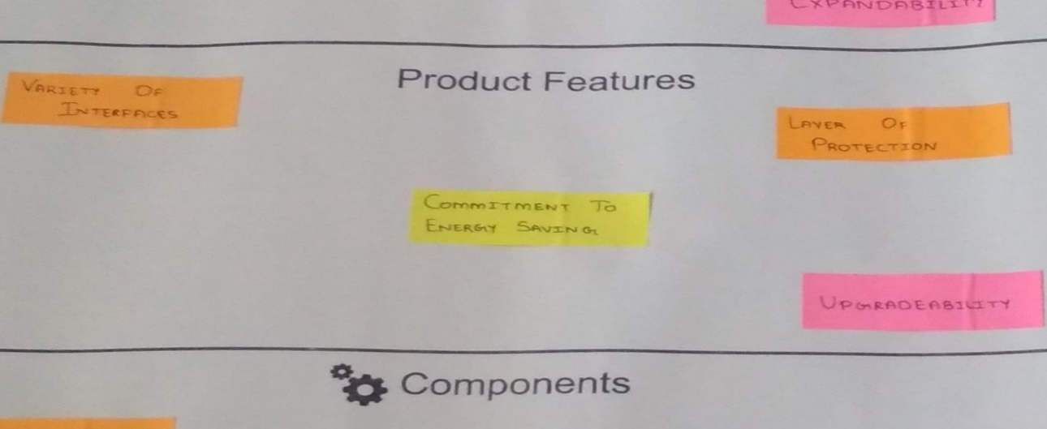

**Product Experience**



Product experience is as follow:

* Convenient

18

**Product Functions**



Product functions are:

* Remote access
* Interoperability
* Expandability

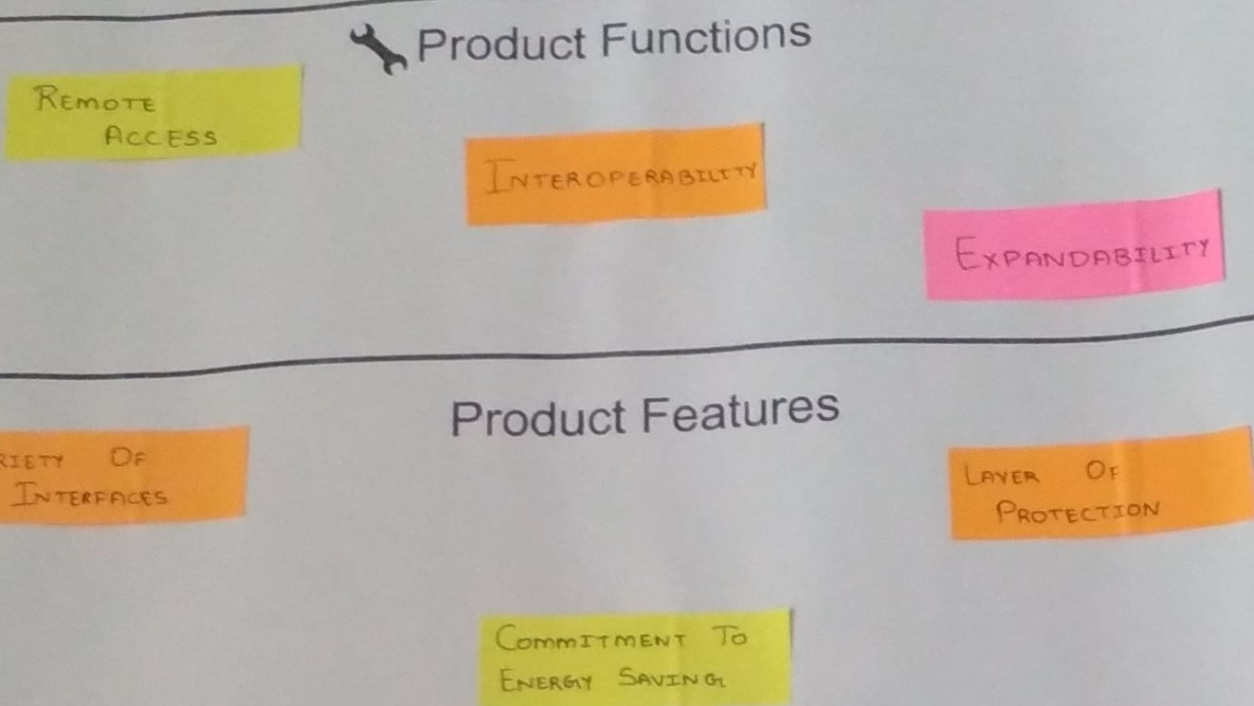

**Reject, Redesign, Retain**

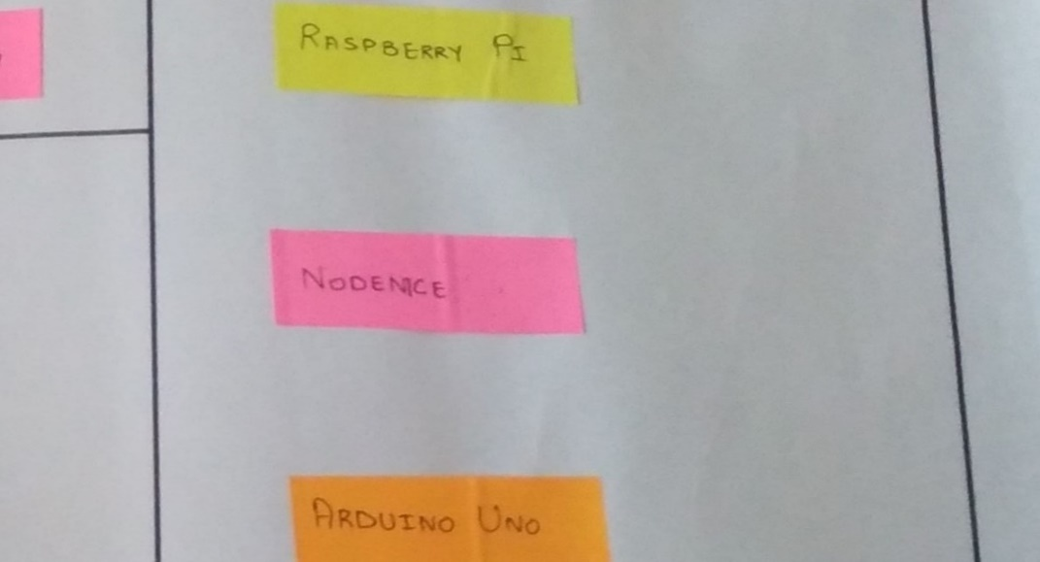



* Raspberry PI
* Nodemce
* Arduino Uno

19

**2.6 Mind Mapping:**

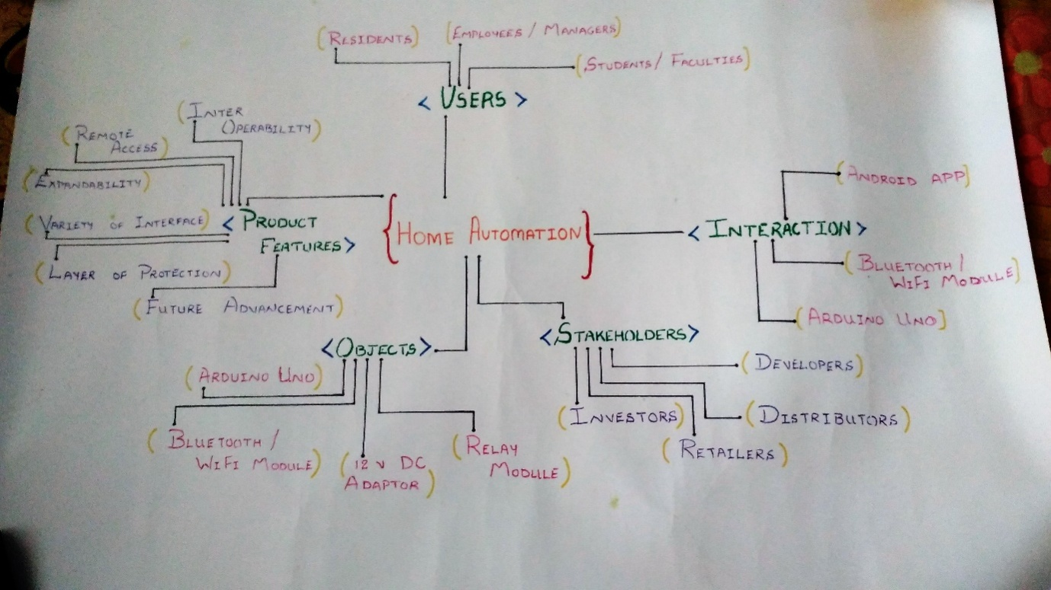



**2.7 Importance of log book**

There are several good reasons for keeping log book as follows:

1. Can go back and find your calculations and keep thoughts together.
2. Legal evidence in case of legal proceedings against you.
3. Legal evidence for intellectual property.

20

**Conclusion:**

By creating various mappings, we found:

* How the project needs to be planned in order to function accurately.
* How the project has to ideally perform.
* What functions the project must have.
* Problems that occur during the planning of the project and how to resolve them.
* How to keep track of every activity performed during the planning and information gathering phase.

21

**2.8 Literature Review**

**1 Keywords**

Home Automation System, Remote control via mobile, SMS messaging, IR sensors, LED array.

**2 Introduction**

The Home Automation project is based on an Raspberry Pi 2 processor, which is supported by 1GB RAM and running at 900 MHz CPU which is over clocked at 1 GHz without damaging the board, In this project an image of the person will be clicked and sent to the user via FTP network , A CMOS camera is placed on the front door of the house which will take the photo, if the stranger tries to enter forcefully an alert message will be sent to the user, and the user is given an option to open the door or lock it right from his smart phone. This project can be customized a lot as it has multiple GPIO ports that can be programmed and they can give the user control over various things from his smart phone like security, surveillance, lighting, energy management, access control, entertainment etc. These interfaces are all possible by the help of the GPIO ports in the Raspberry Pi 2 board. In present times there is an increasing need for Home security due to thefts and threats. And the benefits of automation are obvious. It is like a home where the lights came on after dusk, doors open for the home owner etc. There is also a need for surveillance in today's world, as well as energy management.

Nowadays the increase in various computing devices such as laptop, computers, mobiles etc. shows that users prefer things which are more comfortable to use i.e. rather than physically going to the place and controlling it doing the same thing remotely saves time. For example, if the Admin receives a message saying that there was a break in his house, he/she can connect to the internet and watch the video from the camera which is in the house to know what is happening. By receiving alerts on your device the user are informed of all possible issues occurring in the house and it gives them various possibilities to deal with the problems. This is how an automated system proves useful to people in providing them security, comfort and easily accessible.

**2. Concept Review**

2.1 Proposed System

In this system there is a PIR sensor which is connected to the door this sensor has a 180° range up to 1 to 2 meter approximately. This sensor is very much useful than the normal IR sensor which have a range in a straight line so this sensor is able to detect people even if they come from the side.

When a person comes in range of the sensor it sends a trigger pulse which activates an LED array and the camera, the led provide a good light environmentfor the camera to take a good photo and so there is no problem of a bad photo in which the persons face is not seen which can cause problems.

22

2.2. Hardware description

In this system there are various hardware devices used which are given below:

2.2.1. Raspberry Pi Board

The Raspberry pi 2 board model B has a processor of 900 MHz CPU and 1GB RAM which almost acts like a mini computer. We installed NOOBS in the memory card used for the board and then with the help of NOOBS we can boot the raspberry pi with various operating systems. We have booted it with a LINUX based operating system called Raspbian which is The Raspberry Pi camera module is used in this system to capture photos of the people. It is a 5 Megapixels fixed-focus CMOS camera which can be used to take High-definition videos and images. A 15cm ribbon cable comes with the camera which is used to connect the camera with the Raspberry Pi board (Pierre Raufast, 2013).

**3. Product Description**

3.1 Remote Control Module

For remotely controlling the Raspberry Pi we use an application which connects to the Raspberry Pi by the SSH connection protocol here we give the IP address of the Raspberry Pi to the Application and we run the terminal commands from the application as shown in the figure.

3.2 Messaging via API Module

**Fig.10** Messages send from the API

As shown in the figure 10 we use the API of a messaging website to send a message to the user’s mobile phone which alerts the user about the changes in his house, so he can take the actions according to the message he has received.

**4. System Testing**

In this section we will be testing the various Modules.

**Fig.11** Testing the working of the PIR sensor

As shown in the figure 11 we checked the response time of the PIR sensor and how it activates the camera, the image is clicked and displayed on the monitor. The camera has a red light which indicates that it is active.

**Fig.12** Testing the Motors

In the figure 12 we checked how the motors respond to the signal sent from the mobile phone, also about the time they are active when the signal is sent.

23

**Conclusion**

The proposed project provides security and various ways to control the devices in the house, it makes ones living comfortable and at the same time easily accessible through portable devices like mobile phones. It gives the administrator all the rights to decide which makes it reliable as it always asks before taking a decision, which helps when there are necessary decisions to be taken and they can be taken fast in case of an emergency.

**Future Scope**

The Raspberry Pi is a really compact processor which has a good enough computing power for its size. As now there is an increase in technologies and various portable devices in those devices may be one day the raspberry might also be used as it has multiple GPIO pins which can be programmed and used to interface various devices in the real world and can be controlled with a program in Python.

24

**2.9 Learnings Need Matrix (LNMATRIX)**

LN – Learning Needs Matrix will help us to identify the learning requirements at an early stage along with prioritization of specific learning along with defined time duration/ time allocation for each.

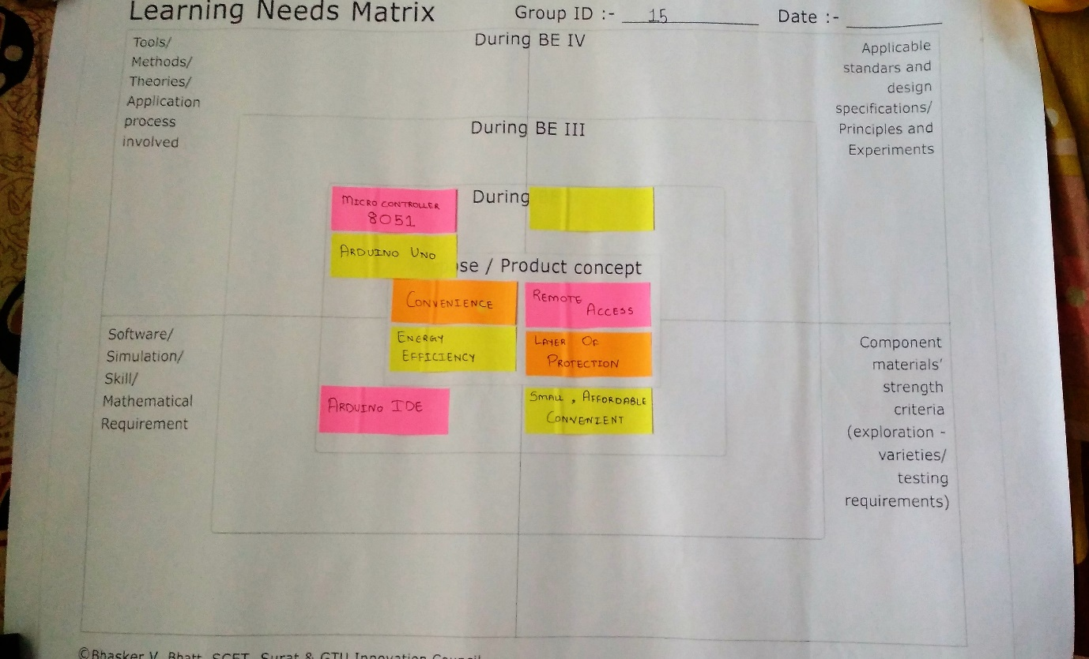



25

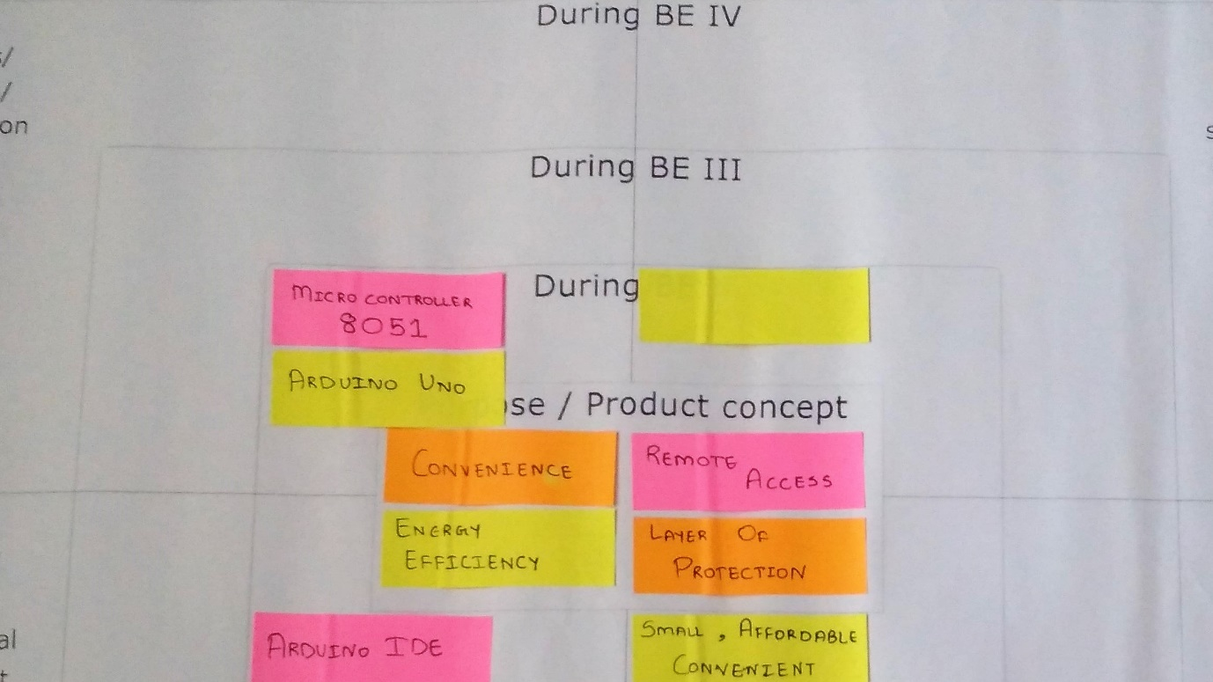**3.1 Design for cost:**

**3.1.1 Hardware support and Estimation**

|  |  |  |
| --- | --- | --- |
| **Sr.No** | **Hardware Requirement** | **Estimate cost** |
|  |  |  |
| 1 | Cameras | 50000-100000 |
|  |  |  |
| 2 | Laptops/PCs | 15000-30000 |
|  |  |  |
| 3 | Mobile/Tablets | 5000-20000 |
|  |  |  |
| 4 | Internet | 200-1000 |
|  |  |  |
| 5 | Compiler | 1000-5000 |
|  |  |  |

**Table: 3.1.1.1 Hardware Cost and Estimation**

26

**3.1.2 Software Estimation**

|  |  |  |
| --- | --- | --- |
| **Sr.No** | **Software Requirement** | **Estimate Cost** |
|  |  |  |
| 1 | OS(Windows 7) | 15000-20000 |
|  |  |  |
| 2 | Microsoft Office | 50000-10000 |
|  |  |  |

**Table: 3.1.1.2 Software Estimate Cost**

**3.1.3 Communication Interface Requirement**

|  |  |  |
| --- | --- | --- |
| **Sr.No** | **Communication Interface** | **Estimate Cost** |
|  |  |  |
| 1 | Internet | 5000-10000 |
|  |  |  |
| 2 | Payment gateway | - |
|  |  |  |
| 3 | Anti-virus | 1000-1500 |
|  |  |  |

**Table: 3.1.1.3 Communication Interface Cost**

27

1. **Rough Prototype Model**

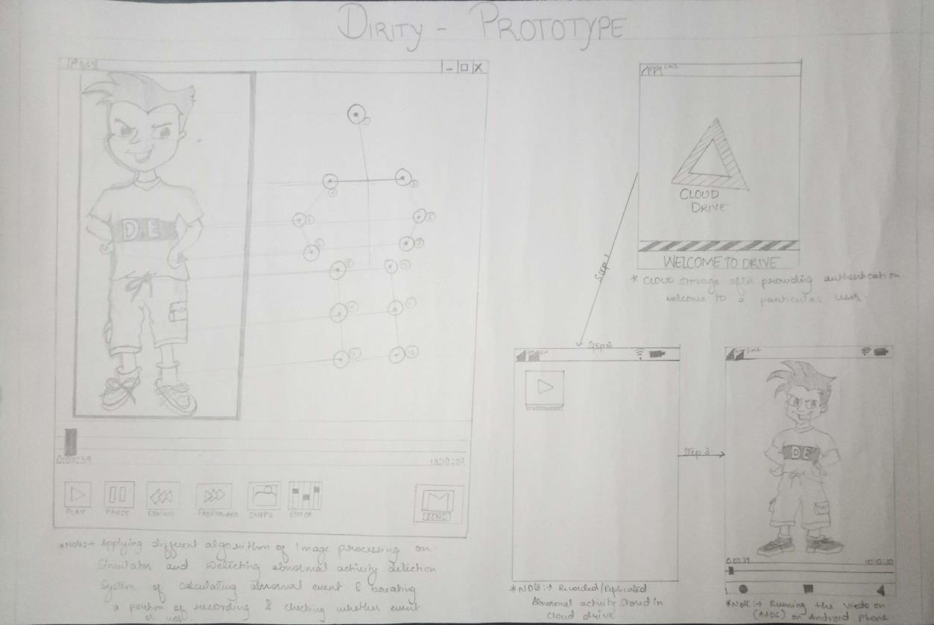

28

**References:**

**Reference research paper**

Amit Narote, Abhishek Dsilva, Selma Misquitta and Palak Khandelwal (2015), Smart home automation using arm11, International Journal of Current Engineering and Technology, vol. 5, pp. 472-476.

Gayatri Kulkarni, Priyanka Gode, Jadi Pratap Reddy and Madhura Deshmukh (2015), Android based smart home system, International Journal of Current Engineering and Technology, vol. 5, pp. 1022-1025.

Pierre Raufast (2013), Raspberry Pi Open CV and camera board, https://thinkrpi.wordpress.com/opencv-andpi-camera-board/

Lady ada (2014), PIR motion sensors, Pyroelectric (Passive) InfraRed Sensors , https://learn.adafruit.com/pir-passive-infrared-proximity-motion-sensor/overview .

Rakesh Ron (2013), L293D Motor Driver IC, http://www.rakeshmondal.info/l293d-motor driver.

Jason Barnett (2014), Controlling DC Motors Using Python with a Raspberry Pi,

http://computers.tutsplus.com/tutorials/controlling-dc-motors-using-python-with-a-raspberry-pi--cms-20051

P.Vigneswari, V.Indhu, R.R.Narmatha, A.Sathinisha and J.M.Subashini (2015), Automated security system using surveillance, International Journal of Current Engineering and Technology, vol. 5, pp. 882-884..

29